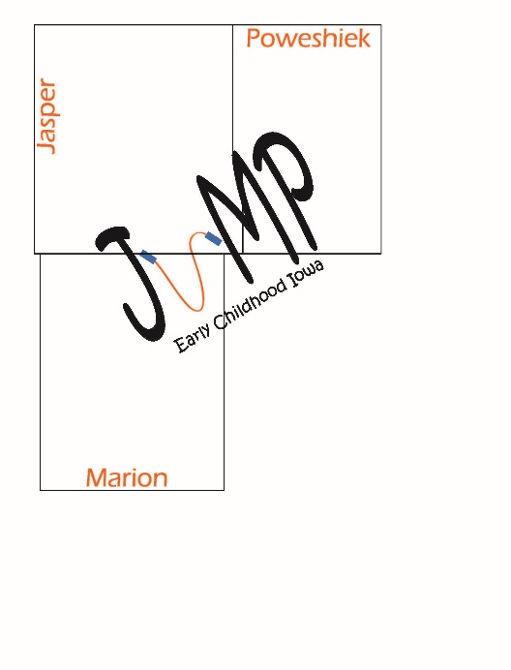**JMP**

**Jasper, Marion & Poweshiek**

**Early Childhood Area**

**Request for Proposal Application**

**Fiscal Year 2024**

## Funding for July 1, 2023 to June 30, 2024

**RFP (Request for Proposal) Schedule for FY24**

|  |  |
| --- | --- |
| **February 24, 2023** | **Call for proposals** |
| **March 31, 2023** | **Proposal due *no later than* 3:00 pm.**  **Email your grant to amy@greaterpcf.org** |
| **April 3 –April 26, 2023** | **RFPs reviewed by JMP Board** |
| **June 2, 2023** | **Notification regarding RFP decisions** |
| **July 1, 2023** | **Contract period begins** |

The JMP Board seeks to support programs that enhance our **VISION**:

*All children, beginning at birth, will be healthy and ready to succeed*.

And strengthen our **MISSION**:

*Collaborative efforts among Jasper, Marion and Poweshiek counties will provide families with young children the opportunities, resources and supports necessary to fulfill our vision*.

While focusing on our **PRIORITIES**:

1. *Providing access to quality preventative health services for children*
2. *Achieving high quality preschool environments with the capacity to serve all children within the JMP ECI area*
3. *Offering high quality family support and education for at-risk families with children ages 0-5*
4. *Providing high quality early education environments with the capacity to serve all children within the JMP ECI area*.

If you have questions please contact:

Amy Blanchard, Director

JMP Early Childhood Area

PO Box 344, 1510 Penrose Street

Grinnell, IA 50112

641-236-5518

amy@greaterpcf.org

Proposals

Guidance for Proposals

1. JMP ECI funding must be used to benefit children pre-birth to 5 years and their families in Jasper, Marion, and Poweshiek counties.
2. Applicants must be willing to comply with federal and state laws regarding confidentiality and non-discrimination.
3. Applicants must demonstrate a commitment and ability to comply with all reporting requirements and state and federal laws, including policies implemented by the JMP ECI Area Board.
4. Applicants must be a not-for-profit entity or group 501(c)(3), or substantially meet the requirements to be certified as not-for-profit, or have a not-for-profit administer the funding.
5. Programs must comply with the funding parameters for Early Childhood Iowa. These guidelines can be found here: [ECI Toolkit Tool G](https://earlychildhood.iowa.gov/sites/default/files/documents/2021-06/Tool%20G%20approved%206%204%2021.pdf). All applicants are strongly encouraged to review these guidelines prior to applying.

Application Process

In order for the application to be given full consideration it must be submitted **before 3:00 pm on Friday, March 31, 2023**. Both mail and email are acceptable forms of application submissions. Please direct applications to the attention of Amy Blanchard, JMP ECI Director, via mail at PO Box 344, Grinnell, IA 50112 or via email at: amy@greaterpcf.org. All other questions or concerns can also be directed to Amy Blanchard at 641-236-5518.

Contracting Period

The contracting period is **July 1, 2023 – June 30, 2024**, contingent upon funding from the State ECI Board. General funding is available for a one-year funding cycle. Funding is **not** guaranteed to be sustainable or continuous from year to year. The State of Iowa has the right to reduce or rescind grant amounts at any time. Early Childhood Iowa will not be responsible for maintaining funding if grant amounts are eliminated or reduced.

Funding Priorities

**Priority** willbe given to proposals for programs/projects that:

1. Demonstrate a clear plan to serve one or more of the priorities as established in the JMP Community Plan.
2. Are a continuation of a successful program/project previously funded by JMP.
3. Are preventative in nature and demonstrate long term results to impact identified needs.
4. Complement the current continuum of services to avoid duplication of services and effort.
5. Promote collaborative and innovative problem-solving to meet the needs of our community.
6. Demonstrate the effectiveness of projects through outcome-based evaluation processes.

Proposal Review Process

The evaluation process has three phases.

1. Each proposal will initially be reviewed by the Director for completeness. All forms, signatures, and format requirements must be present before the proposals will be sent to the second phase. Proposals lacking the required elements will be returned to the applicant and will not be reviewed.
2. Each proposal will be given to every board member for review based upon the evaluation criteria included with this application. Each applicant will be offered the opportunity to give an oral presentation to the Board. Oral presentations are not mandatory. Proposals will be reviewed and scored with a consensus scoring process. Board members will discuss each proposal evaluation then score each on a scale of 0 to 4. The JMP Early Childhood Iowa Board reserves the right to select the provider(s) that will best meet the service objectives, not necessarily proposals with the highest scores.
3. The JMP Early Childhood Iowa Board will determine funding for each proposal. The meeting is open to the public.

Notification of Awards

Applicants will be notified via email whether their application is being funded. All correspondence will be directed to the contact person listed on the completed application cover sheet.

Review of Award Decision

Applicants may request review of the award decision by filing a written appeal to JMP Early Childhood Iowa Area Board, Attn: Brian Kingrey, PO Box 344, Grinnell, IA 50112.

Appeal Process

Applicants have the right to appeal the funding decisions based upon a showing that the policies and procedures governing the grant selection process have not been properly applied. The appeal process begins on the postmarked date of the written notification to the applicant of the grant committee’s decision. Appeals should be in writing and filed with the Chairperson of the Board (Brian Kingrey) within (5) five working days of the date of written notification of funding decisions to the applicant. It is the responsibility of the applicant to assure that appeals are received on or before the (5th) fifth working day of the appeals process. Appeals received after the (5th) fifth day will not be reviewed.

* All appeals shall clearly state how the selection failed in following the rules of the grant process as governed by the policies and procedures outlined in the RFP material provided to all applicants. The request must also describe the remedy sought.
* The Early Childhood Iowa Board will review the appeal and gather information regarding any infractions of the process.
* At the next regularly scheduled meeting the Early Childhood Iowa Board will determine if there has been a violation of process and will rule on the appeal. Final decision will be made by a quorum of the Early Childhood Iowa Board.
* The Early Childhood Iowa Board chair then issues the written decision to the appeal to the person(s) who submitted it.

Conflict of Interest

To avoid any conflict of interest in the above funding determination process, any members of the JMP Early Childhood Iowa Board who have a direct interest or substantial related interest in a particular funding proposal will not participate in evaluation of that proposal. An example of a direct interest in a proposal would be an employee or board member of an agency submitting a proposal. An example of a related interest in a proposal would be a relative of an employee or board member of an agency submitting a proposal. For further explanation see Tool V on www.earlychildhoodiowa.org.

Application Content

Applicants must submit a cover sheet, a narrative sheet and a budget form(s) in that order. Narrative questions must be answered in the order the questions are given. Do not use a font size smaller than 10 point for any of the components of the application. Do not include confidential information, as all applications are public record.

Complete a cover sheet and narrative **for each program/project for which you are applying for funding.** As for the budget form, please follow these instructions:If applying for funding for one program/project, only the first page of the budget form should be completed using line items similar to those on the second page. If applying for funding for more than one program/project, the first page should be completed showing only a total for each program/project, and the second page should be completed with line item detail for each program/project. Additional pages will be provided if needed electronically, or copies can be made. Double click inside the form to input information.

Release of Claims

With the submission of a proposal, each applicant agrees that it will not bring any claim or have any cause of action against the Early Childhood Iowa Board based on any misunderstanding concerning the information provided herein or based on the Board’s failure to provide the applicant with information.

Questions should be addressed to:

Amy Blanchard, JMP ECI Director

PO Box 344, 1510 Penrose Street

Grinnell, IA 50112

641-236-5518

amy@greaterpcf.org

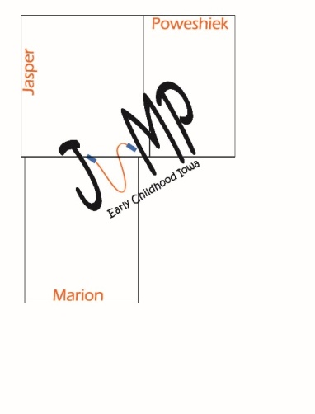

**JMP EARLY CHILDHOOD AREA PROPOSAL for FUNDING**

**Application Cover Page**

|  |  |  |
| --- | --- | --- |
| **Legal Name of Organization/Applicant** | | |
| **Name of Proposed Program/Project** | | |
| **Address** | | **City, State, Zip** |
| **Organization Phone** | **Organization Email** | |
| **Contact Person and Title** | | |
| **Contact Person Phone** | **Contact Person Email** | |
| **Federal Tax ID Number** | **New or Existing Program/Project** | |
| **Amount of funding requested:**  **Amount of other funding sought:**  **Amount of other funding secured:** | | |
| **Program/Project Purpose Statement (fill in the blanks)**  **The purpose of** ……………………………………………………………………… **is to provide** …………………………………………………………………………………………………. **for** ………………………………………………………………………………………………… **in order to** ………………………………………………………………………………………………………….. | | |
| **I certify that I am duly authorized to commit and make assurances for the applicant, and will comply with all the provisions set forth in this Request for Proposal. To the best of my knowledge, the information contained in this application is correct and complete.**  **Signature: Date:** | | |

**JMP EARLY CHILDHOOD AREA PROPOSAL for FUNDING**

**Application Narrative**

*The total narrative section is not to exceed 4 pages. When applicable, please define acronyms and use concise, common language to describe your program.*

**1. OVERVIEW of ORGANIZATION and PROGRAM/PROJECT**

Briefly describe the purpose, mission and history of your organization. Briefly describe the proposed program/project and its key achievements.

**2. PROGRAM GOALS**

What are the program/project goals and how do they align with Early Childhood Iowa priorities? Please identify the number of children, families, providers and or visits/services that will be served by this program during the fiscal year. If applicable, include a timeline for implementation of services, particularly for new programs/services.

**3. MODEL and PRACTICES**

Describe the evidence or research basis of the proposed program/project or describe the promising practice model, if applicable. Please describe and site the source of research, evidence or promising practices information.

(**Evidence-based** programming is defined as a program that has completed a randomized control trial conducted by an independent researcher that has demonstrated positive results for children and families. It can also include research conducted by the program that has been published in a peer reviewed journal that also demonstrates positive results for children and families. **Research-based** programs may be based on sound research but do not have the on-going monitoring to ensure fidelity to the model that evidence based programming includes. **Promising practice** programs may have completed an evaluation which has not yet been published so that research has not been verified by an independent panel.)

**4. MEASURABLE OUTCOMES**

Is the program/project one for which data can be collected and analyzed to know if it is working the way it should? Describe the methods and tools used in collecting, reporting and monitoring the program’s performance.

**5. IMPACT STATEMENT**

Does the program/project address unmet community needs? Does it have the power to have an impact on positively changing the conditions, skills, attitudes or behaviors of the children and families served? Is the program uniquely suited to fulfill the JMP priorities?

**6. FEASIBILITY**

Is the program/project cost effective, affordable, and sustainable? Could it be funded from multiple sources? If new, is it timely in that it can be acted upon and implemented within the year?

**7. COMMUNITY PARTNERSHIPS**

Is your program/project building and maintaining community partnerships? If yes, explain the type of collaborative relationships with which you are currently engaged. If no, do you have a plan to coordinate services with other community resources?





|  |  |  |  |  |  |  |
| --- | --- | --- | --- | --- | --- | --- |
| JMP Early Childhood Iowa RFP Scoring Rubric | | | | 0 1 2 3 4 | | |
| **Applicant's Name**: | | | **Reviewer** | | | |
| **Scoring Guide:** | **0** | Applicant has not addressed any of the guidelines in the narrative or has provided a narrative that is vague, limited in scope or incomplete. Applicant did not address how JMP’s priorities would be met. | | | | |
| **1** | Applicant has addressed some of the guidelines in the narrative. Applicant does not clearly indicate if JMP’s priorities would be met. | | | | |
| **2** | Applicant has adequately addressed the guidelines in the narrative. Applicant indicates an adequate ability to meet JMP’s priorities. | | | | |
| **3** | Applicant has provided a good and complete narrative. Applicant clearly demonstrates a high degree of ability to meet JMP’s priorities. | | | | |
| **4** | Applicant has provided a clear and compelling narrative with relevant supporting information. Applicant’s program goes above and beyond the minimum requirements and indicates a superior ability to meet JMP’s priorities. | | | | |
| **Criteria and criteria description** | | | | | Satisfactory | Unsatisfactory |
| 1. **Overview and Need:** Applicant adequately describes the purpose, mission and history of its organization. Applicant adequately describes the proposed program/project and its key achievements. | | | | |  |  |
| Reviewer notes: | | | | | | |
| 1. **Program Goals:** Applicant communicates a set of goals that align with the JMP Early Childhood Iowa priorities. Applicant defines the number of children and families served or visits provided. Applicant outlines a reasonable timeline, if applicable. | | | | |  |  |
| Reviewer notes: | | | | | | |
| 1. **Model and Practices:** Applicant describes and sites use of research-based, evidence-based and/or generally promising approaches. | | | | |  |  |
| Reviewer notes: | | | | | | |
| 1. **Measurable Outcomes:** Applicant displays evidence that the program/project’s outcomes are measurable and outlines the process for collecting and reporting required performance measures. | | | | |  |  |
| Reviewer notes: | | | | | | |
| **Criteria and criteria description** | | | | | Satisfactory | Unsatisfactory |
| 1. **Impact Statement:** Applicant is able to convey ways in which the program/project will impact community needs of children and families. | | | | |  |  |
| Reviewer notes: | | | | | | |
| 1. **Feasibility:** Applicant is persuasive in the project’s account of cost effectiveness, affordability and sustainability. | | | | |  |  |
| Reviewer notes: | | | | | | |
| 1. **Community Partnerships:** Applicant adequately describes the collaborative relationships of the program/project. | | | | |  |  |
| Reviewer notes: | | | | | | |
| 1. **Budget:** Applicant presents a cost-effective, clear and justified budget. | | | | | | |  |  |
| Reviewer notes: | | | | | | |
| Please use this space for any final overarching comments concerning the application in its entirety: | | | | | | |